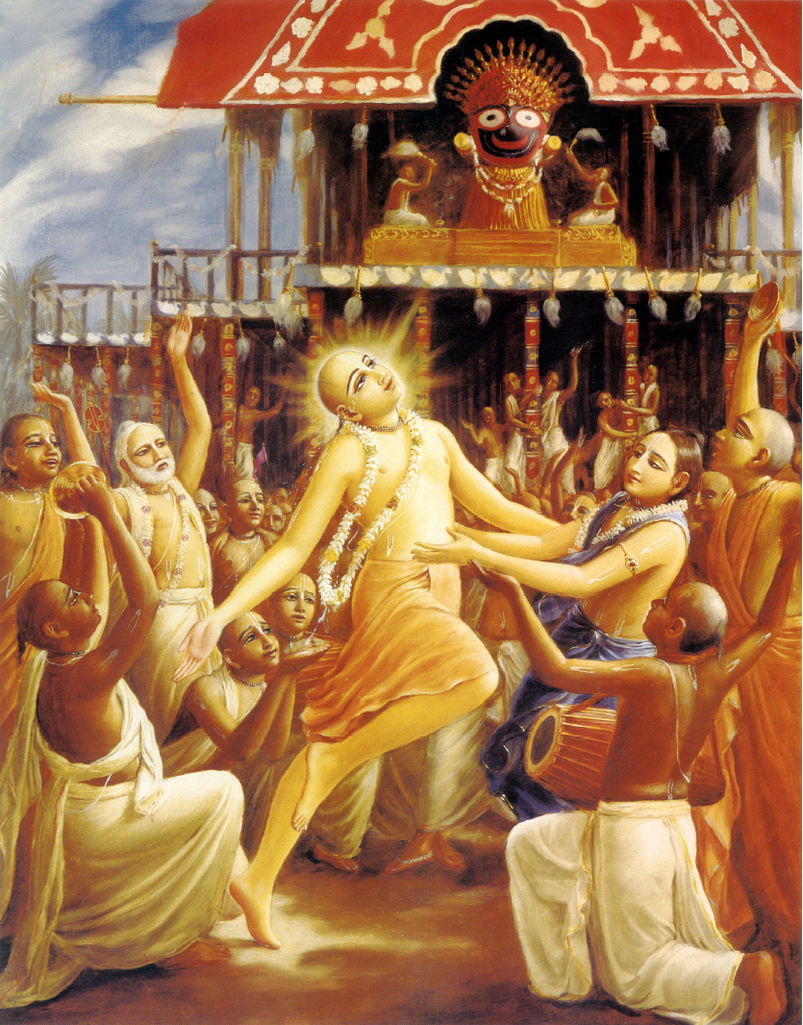

February 2011 Edition
www.soldiersofgodhead.yolasite.com

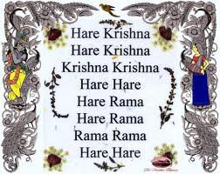
Contents
Sr. no Topic Page no.
- Mantra Meditation 4

- Seeing God 8

Dutch Local Government Appoints

Land to ISKCON The Hague 13

- Kanpur Ratha Yatra and
Bhumi Puja 14
- Wonderful Prasadam 19

- Mantra Meditation
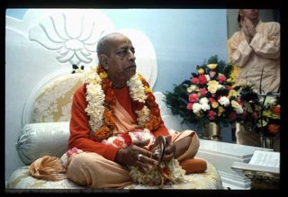
Chanting the transcendental vibration: Hare Krishna, Hare Krishna, Krishna Krishna, Hare Hare,
Hare Rama, Hare Rama, Rama Rama, Hare Hare...is the sublime method for reviving our transcendental consciousness, or Krishna consciousness.
As living spiritual souls, we are all originally Krishna conscious entities, but due to our association with matter from time immemorial, our consciousness is now polluted by the material atmosphere, called maya, or illusion.
And what is this illusion? The illusion is that we are all trying to be lords of material nature, while actually we are under the grip of her stringent laws. When a servant artificially tries to imitate the all-powerful master, he is said to be in illusion.
We are trying to exploit the resources of material nature, but actually we are becoming more and more entangled in her complexities. Therefore, although we are engaged in a hard struggle to conquer nature, we are becoming ever more dependent on her. This illusory struggle against material nature can be stopped at once by revival of our eternal Krishna consciousness.
Krishna consciousness is not an artificial imposition on the mind. This consciousness is the original energy of the living entity. When we hear and chant the transcendental vibration:
Hare Krishna, Hare Krishna, Krishna Krishna, Hare Hare,
Hare Rama, Hare Rama, Rama Rama, Hare Hare...
this consciousness is revived.
This simplest method of meditation is recommended by learned authorities for this age. By practical experience also, one can perceive that by chanting this maha-mantra, or the great chant for deliverance, one at once feels transcendental ecstasy coming through from the spiritual stratum.
In the material concept of life we are busy in the matter of sense gratification, as if we were in the lower, animal stage. A little elevated from this status of sense gratification, one engages in mental speculation for the purpose of getting out of the material clutches. A little elevated from this speculative status, when one is intelligent enough, one tries to find out the supreme cause of all causes, within and without. And when one is factually on the plane of spiritual understanding, surpassing the stages of sense, mind, and intelligence, one is situated on the transcendental plane. The chanting of the Hare Krishna mantra is directly enacted from this spiritual platform, and thus this sound vibration surpasses all lower strata of consciousness—namely sensual, mental, and intellectual.
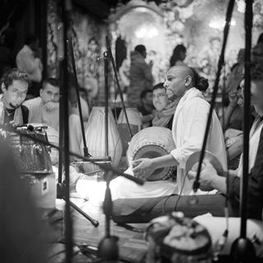
There is no need, therefore, to understand the language of the mantra, nor is there any need of any mental speculation or intellectual adjustment for chanting this maha-mantra. It springs automatically from the spiritual platform, and thus anyone can take part in the chanting without any previous qualification and dance in ecstasy. We have seen this practically. Even a child can take part in the chanting and dancing.
Of course, for one who is too entangled in material life, it takes a little more time to come to the standard point, but even such a materially engrossed person is very quickly raised to the spiritual platform.
When the mantra is chanted by a pure devotee of the Lord, it has the greatest effect on hearers, and therefore this chanting should be heard from the lips of a pure devotee of the Lord, so that immediate effects can be achieved. As far as possible, chanting from the lips of non-devotees should be avoided, just as one would avoid milk touched by the lips of a serpent because it has poisonous effects.
The word Hara is a form of addressing the energy of the Lord, and the words Krishna and Rama (which mean "the highest pleasure eternal") are forms of addressing the Lord Himself. Hara is the supreme pleasure energy of the Lord, and when addressed as Hare in the vocative, She helps us to reach the Supreme Lord.
The material energy, called maya, is also one of the multi-energies of the Lord, and we, the living entities, are the marginal energy of the Lord. The living entities are described as superior to the material energy. When this superior energy is in contact with the inferior energy, an incompatible situation arises, but when the superior marginal energy is in contact with the spiritual energy, Hara, the living entity is established in his happy, normal condition.
These three words, namely Hare, Krishna, and Rama, are the transcendental seeds of the maha-mantra. The chanting is a spiritual call for the Lord and His internal energy Hara to protect the conditioned soul. This chanting is exactly like the genuine cry of a child for its mother. Mother Hara helps the devotee achieve the grace of the Supreme Father, Hari or Krishna, and the Lord reveals Himself to the devotee who chants this mantra sincerely.
Therefore no other means of spiritual realization is as effective in this age of quarrel and hypocrisy as the chanting of the maha-mantra: Hare Krishna, Hare Krishna, Krishna Krishna, Hare Hare,Hare Rama, Hare Rama, Rama Rama, Hare Hare.

Seeing God
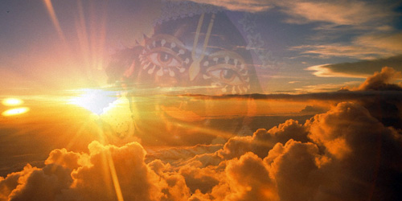
A conversation with His Divine Grace A.C. Bhaktivedanta Swami Prabhupada
Srila Prabhupada: So religion means to abide by the laws of God. That’s all. It cannot be “Hindu,” “Muslim,” “Christian.” Take the state law: in the state there are many persons, many citizens of the state—but the law does not stipulate that “This is for the Christians,” “This is for the Jews,” “This is for the black men,” “This is for the white men.” The law is not like that.
The law is the same for everyone. You cannot say, “This is the black law,” “This is the white law.” No. That is not very scientific. The scientific understanding is that God is there and we are all under His law. God is great, we are His subordinates. and we have to obey His orders. That is the genuine spiritual platform. That is genuine religion. Am I right or wrong?
Reporter 3: You’re right.
Srila Prabhupada: Therefore you cannot say “Christian religion,” “Hindu religion,” “Muslim religion.” Religion is religion. God is neither Christian nor Hindu nor Muslim. God is God. God is one.
God is one. But we understand Him from different angles of vision. And those different angles of vision may be called “the Christian angle of vision” or “the Hindu angle of vision” or “the Jewish angle of vision” or “the Muslim angle of vision.” But that is simply an angle of vision.
Now, let us take the example of the sun. Here in Australia, June is a cooler month, and we may see the sun as not so warm. But you ask some African friend whether the sun is warm. “Oh, it is very warm.”
So his appreciation of the sun from his angle of vision is different from your appreciation here.
But factually, the sun is one and the same. There is no such thing as the “Australian sun” or the “African sun.” So factually, there is no such thing as “Hindu religion,” “Muslim religion,” “Christian religion.” You see’? These conceptions are all due to our sophisticated mind.
Just as God is one, religion is one: you must know what God is, and you must know what His order is—and you must abide by it. Then you are religious. That’s all. We are preaching like that.
Reporter 6: So it seems you are saying, then, that by holding to their conception of a “Muslim” or “Jewish” or “Hindu” or “Christian” God, people are not actually realizing God. And yet one of the most important purposes of human life is to realize God, correct?
Srila Prabhupada: Yes. That is the only purpose. Except for fulfilling that purpose, anything we are doing is animalism. We are simply jumping about, just as the dog is jumping about, that’s all.
If we do not realize God, what is the difference between our life and a dog’s? A dog is thinking, “I am a very stout bulldog.” And a man is thinking, “I am a very well-to-do Dutchman.” So what is the difference between the dog and the man?
Their mentality is the same. The dog is thinking, “I am this body, “and the man is equally thinking, “I am this body.” But when one understands, “I am not this body—I am a spirit, and I emanate from the supreme spirit,” that is humanity.
Reporter 6: So, Your Divine Grace, have you realized God?
Srila Prabhupada: What do you think? What is your opinion?
Reporter 6: I can’t say.
Srila Prabhupada: Then if I say “Yes”, what will you understand? If you are not yourself expert, then even if I say “Yes; I am God realized,” how will you take it as truth? If you do not know what God realization is. then how can you ask this question, and how will you be satisfied with the answer?
Reporter 6: Well. what is God realization?
Srila Prabhupada: First make sure you understand this idea.
Now, for instance, if one medical man asks another man, “Are you a medical man’.” and the other man says “Yes,” then the first man will understand by their exchange of technical terms whether the second man is truly a medical man. But unless one is himself a medical man, what is the use of asking another man, “Are you really a medical man?”
So for you it is useless to ask about my having realized God, unless you are prepared to accept my answer. Are you?
Reporter 6: Yes.
Srila Prabhupada: Then it is all right. I am God realized. I am seeing God at every moment.
Reporter 5: Your Divine Grace, do you see meditation as a means to God realization?
Srila Prabhupada: Yes, meditation is also a means, but you cannot meditate now, because you do not know what God is. Meditation means meditation upon something or someone. But if you do not know what God is, upon what or whom will you meditate?
First of all, you must know about God. For instance, we know about God, Krishna, and in the Bhagavad-gita Krishna says, man-mana bhava mad-bhaktah: “Always think of Me.” So we meditate upon Krishna. This is perfect meditation—because meditation means to think of God. But if you do not know what God is, how will you think of Him?
Reporter 3: Your Divine Grace, it is written in many scriptures that God is light.
Srila Prabhupada: God is everything. God is darkness, also. Therefore the Srimad-Bhagavatam clearly defines God as “that being from whom emanates everything that exists.” Light exists, yet darkness also exists. So just as light emanates from God, darkness also emanates from God.
Reporter 5: Is meditation a way to see God inside yourself?
Srila Prabhupada: Yes. That is the proper definition of meditation. Dhyanavasthita-tad- gatena manasa pashyanti yam yoginah: by concentrating their mind upon God, the yogis try to see Him within their heart.
But to concentrate your mind on God and ultimately see Him, you must first know what God is. In our institution, for instance, our students first learn “what God is—God’s attributes. In that at way they can think of God. But if you have no idea of God, how will you think of Him?

Dutch Local Government Appoints Land to ISKCON The Hague

On 18 February 2011, the day after Sri Nityananda Prabhu ́s appearance day the long awaited decision pertaining the appointment of land for a new temple in The Hague, The Netherlands, was made by the local Dutch governing authorities in favor of ISKCON and other religious organizations. A consortium of three religious organizations, International Society for Krishna Consciousness, Arya Samaj Nederland and Siri Gurudwara Singh Sbha will be building three temples side by side.

- Kanpur Ratha Yatra and Bhumi Puja
By Basu Ghosh Das for ISKCON News on 14 Feb 2011
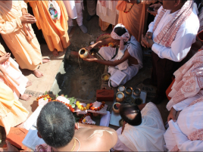
Bhumi puja at the Kanpur ISKCON temple site
Kanpur is India's tenth largest city, and the largest city in Uttar Pradesh with a population of approximately fifty lakhs (five million). Kanpur is famous as an industrial and business center. Kanpur is located on the bank of the holy Ganga nadi (Ganges River), some three hundred and fifty kilometers Southeast of Vrindavan.
On Monday February 7, 2011, ISKCON Kanpur organized a grand “Jagannath Rathayatra festival” at Kanpur. Beginning at the well known park at “Phul Bhag” (“park of flowers”) at around 2 PM, the procession, accompanied by a large group of devotees from ISKCON centers at Bombay, Vrindavan, Mayapur, Lucknow, Patna, Allahabad, Benares, Jhansi, and other places began it's journey though a long stretch of Kanpur's “old market” area.
Kanpur Commisioner Sri Amit Kumar Ghosh inaugurated the procession. He addressed the devotees from atop Lord Jagannath's Rath, performed the inaugural arati to Lord Jagannath and swept the road in front of the Lord's Rath as per the ancient tradition at Puri, where the Gajapati Maharaj sweeps the road in front of the Rath to symbolize that he is a servant of the Lord.
ISKCON leaders Gopal Krishna Goswami, Bhakti Purushottam Swami, Subhag Swami, Prabodhananda Saraswati Swami, Deena Bandhu Das, Basu Ghosh Das, Braja Bihari Das, Shree Jeeva Das, Kapiladev Das, Janardan Das, Vaishnav Das, Krishna Kripa Das, Radhakrishna Das, Nityananda Ram Das, Surapati Das, and many others, all invited by ISKCON Kanpur temple president and zonal secretary for Uttar Pradesh, Devakinandan Das, participated in the Rathayatra.
The next day, Tuesday, February 8, 2011, Radhanath Swami and Radheshyam Das joined with the other devotees to participate in the Paatotsav, bhumi puja, and installation of Ananta Shesh, both in a very fancy “pandal” (tent), erected next to the site for the construction of a grand temple for Sri Sri Radha Madhava.
The Deities of Sri Sri Radha Madhava were installed a year back on the same day at ISKCON Kanpur, which is located on the “Bithoor Road”, on the outskirts of Kanpur city.
Bithoor is a holy place situated eight kilometers (five miles) from ISKCON Kanpur. In the Puranas, Bithoor, situated on the banks of the Ganga, is referred to as “Brahmavarta”, the “center of the Universe”. Bithoor is also situated nearby the “Valmiki ashram”, where the “adi-kavi” (original poet), the sage Valmiki composed the Ramayana (also known as the “Valmiki Ramayana”) in twenty four thousand Samskrita verses, ages ago!
Shitalanga Gauranga Das and Sevatulya Das led the group of devotees in a large fire sacrifice and other rituals connected with the bhumi puja an installation of Ananta Shesh. Construction of the new temple project is to begin immediately.
Devakinandan Das announced a generous donation by Sri M.K. Jalan of Rupees twenty five lakhs (Rs. two and a half million - US dollars fifty thousand) towards the temple construction. The projected budget for the project at Kanpur is Rupees thirty crore (Rs. three hundred million - US dollars six million).
Senior ISKCON sannyasis and leaders, as well as members of the ISKCON Kanpur temple advisory committee, such as Chairman Sri S.K Paliwal, Vice Chairman Sri Mahendra Agrawal, Secretary Sri Chugnuji, long time ISKCON Juhu Bombay Architect Sri Premnath, Sri Raj Kumar Lohia, Sri Bal Krishna Shreya, Sri Ompraksh Dalmia, Sri Gopal Krsna Kejriwal, Sri Tilak Raj Sharma and Sri Pawan Kumar Agrawal were seated on the stage and spoke after the conclusion of the bhumi puja festival.
Devakinandan Das in his address to the assembly after the bhumi pointed out that Srila Prabhupada had written seventeen letters wherein he stressed the necessity of ISKCON establishing a center and building a temple at Kanpur. ISKCON Kanpur now has twelve acres of land where the project will be developed. Already a temporary temple, ashram and goshalla are functioning on the land.
Devakinandan Das thanked ISKCON Pune temple president Radheshyam Das of ISKCON Pune for sending six brahmacharis to assist the project full time, including the temple's Co-President.
After the speeches, there were several cultural programs and bhajanas and kirtans by gurukula students from ISKCON Vrindavan.

Wonderful Prasadam
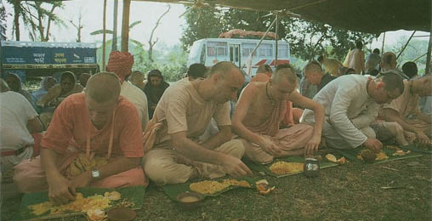
by Rohininandana Dasa
In many places in his books Srila Prabhupada describes the wonders of prasadam, food prepared with devotion and offered to Krishna. Prabhupada discusses such merits of prasadam as how it effectively immunizes one against the contamination of the material nature, how it frees one from becoming a ghost after death, and even how it is considered ecstatic nectar from the lips of Lord Krishna. In the Chaitanya-charitamrita (Madhya-lila, 4.93, purport) Srila Prabhupada writes:
The Krishna consciousness movement vigorously approves this practice of preparing food, offering it to the Deity, and distributing it to the general population. This activity should be extended universally to stop sinful eating habits as well as other behavior befitting only demons. A demoniac civilization will never bring peace to the world… . When the people take to eating only prasadam offered to the Deity, all the demons will be turned into Vaishnavas… . It is then and then only that a peaceful condition can prevail in society.
Because prasadam is sanctified food and should be eaten with respect, we speak of eating prasadam as “honoring” or “respecting” it. Srila Prabhupada relished respecting the Lord’s prasadam and enjoyed seeing others do so. In early ISKCON days he cooked and distributed the Sunday “love feast.” And he kept a jar of syrupy gulabjamuns on hand for any of his spiritual children who might feel peckish. The sweets became known as “ISKCON bullets”—tasty weapons against maya. Prabhupada once popped a gulabjamun into his mouth and exclaimed, “We are eating our way back to Godhead!” Even in 1977 in Vrindavana, after months of fasting because of what would prove a fatal illness, Prabhupada called for his senior leaders, and in a faint, concerned voice he inquired, “Are the devotees getting enough prasadam?”
Once, after a festival in Mayapur, West Bengal, Prabhupada looked out from his veranda and saw some women and children licking used banana-leaf plates thrown on the rubbish heap. With compassionate intensity he said that no one within ten miles of an ISKCON temple should ever go hungry.
Preparing Prasadam
The Chaitanya-charitamrita offers detailed lists of preparations cooked for Krishna and then relished as krishna- prasadam by Lord Chaitanya and His devotees. Lord Chaitanya was concerned that prasadam should be served as nicely as possible, and He often served the devotees Himself. Of course, no one would eat until the Lord had begun, and so after serving everyone for a while He had to sit down and begin eating, as some of His senior followers continued serving.
With this background the members of the Krishna consciousness movement have been busy for the last thirty years cooking and distributing large amounts of prasadam, and therefore the movement has sometimes been referred to as “the kitchen religion.”
Prasadam, which literally means “mercy,” nourishes the body, mind, and soul. It can liberate anyone from material bondage and bestow krishna- prema, love of Godhead. Prasadam is so powerful because food offered to the Lord becomes transformed into a spiritual substance nondifferent from Him. In a purport to Bhagavad-gita (4.24) Srila Prabhupada explains how this is so: “The Absolute Truth covered by maya is called matter. Matter dovetailed for the cause of the Absolute Truth regains its spiritual quality.”
From this quotation we can see how the concept of prasadam extends beyond food to anything with a connection to Krishna. As soon as something or someone is connected to Krishna, it, she, or he becomes spiritualized—Krishna-ized.
The secret of this conversion is love. Krishna is attracted by the humility and love of His devotee. The spice of love is the tasty ingredient that induces the Lord to eat an offering. Devotees therefore try to do everything with love. Their words, thoughts, and actions are heartfelt.

Offering with Love
The Chaitanya-charitamrita relates that the great devotee Madhavendra Puri saw his Deity, Gopala, eat a large offering of food and replace it with spiritual food, prasadam. Although the prasadam looked the same, the unoffered food had become transformed.
Srila Prabhupada says that to achieve the same result is very easy. “Even the poorest of the poor, without any kind of qualification,” can offer Krishna something, he says. If anyone offers even a leaf or a little fruit or water in “genuine love,” the Lord will be pleased to accept it.
We can develop the required love for Krishna in the company of those who already love Him. We get that company in two ways: by physical proximity to a pure devotee and, more important, by associating with a pure devotee’s instructions. So in the absence of the physical association of a devotee, when we, for instance, cook something at home under his direction, we are in his company. And when, with whatever love to which we have access, we make our offering to Krishna through such a pure devotee, we can be confident he will offer it to the Lord on our behalf and the Lord will accept it.
Eating Our Way Home
We'll be able to “eat our way” home to the spiritual world, where at lunch time Krishna and His cowherd-boy friends sit together on the sandy bank of the Yamuna River, where they have transcendental fun discovering the delicious sweets in their lunch boxes, where they feed one another, steal from one another, pretend to steal from one another, play all kinds of childish pranks, and laugh.
And one day, like these ever young boys and all other inhabitants of the spiritual world, we’ll have no need to eat to live. Our eating will be a way of relishing loving feelings. We will be so fully immersed in and saturated by pure love that we will have no use or need for anything else. Our bodies, composed of pure spiritual essence nondifferent from ourselves, will express our love for Lord Krishna and for one another. We will then know what it means to wear our hearts on our sleeves.
Until such a time, we can continue with confidence with our Krishna conscious practices and as often as possible respect prasadam in the company of family and friends. To help us honor Krishna’s prasadam with devotion, before we sit down to eat we can recite the following prayer by Srila Bhaktivinoda Thakura in Bengali, English, or both:
sharira avidya-jal
jodendriya tahe kal
jive phele vishaya-sagore
ta’ra madhye jivha ati
lobhamoy sudurmati
ta’ke jeta kathina samsare
krishna baro doyamoy
koribare jivha joy
sva-prasad-anna dilo bhai
sei annamata pao
radha-krishna-guna gao
preme dako chaitanya-nitai
“O Lord, this material body is a lump of ignorance, and the senses are a network of paths leading to death. Somehow or other we have fallen into the ocean of material sense enjoyment, and of all the senses the tongue is the most voracious and uncontrollable. It is very difficult to conquer the tongue in this world. But You, dear Lord Krishna, are very kind to us. You have given us this nice prasadam just to control the tongue. So now let us take this prasadam to our full satisfaction and glorify Their Lordships Sri Sri Radha and Krishna, and in love call for the help of Lord Chaitanya and Prabhu Nityananda.”

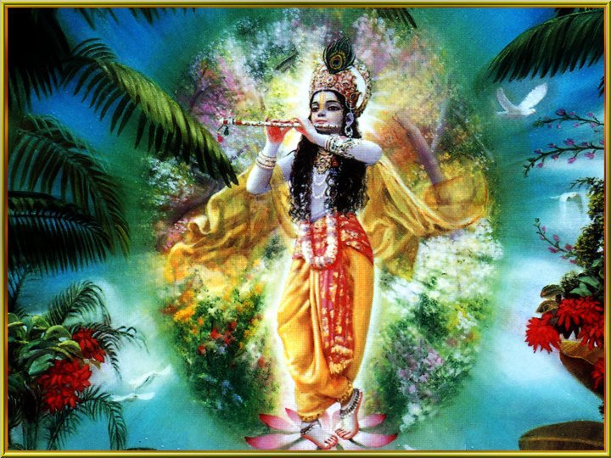
Krishna-The Supreme Personality of Godhead
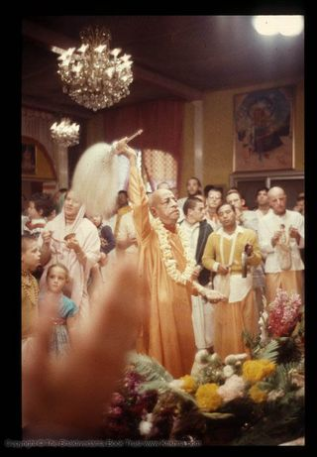
Dedicated to His Divine Grace A.C. Bhaktivedanta Swami Prabhupada, Founder Acharya of the International Society for Krishna Consciousness.
Dedicated in the humble service of Lord Sri Krishna and Srila Prabhupada.

My special thanks to
www.krishna.com and www.Iskconnews.com

Written, Edited, Published and Distributed by,
Rasabihari Das (Vinay .D. Chakraborty)

For more information visit:- www.soldiersofgodhead.yolasite.com
Do send us your views, comments, suggestion and questions to vinay.chakraborty@yahoo.com

Hare Krishna!

